Commercial Real Estate

Out of the shadows
Low-profile self-storage and senior living developments are suddenly in the spotlight

By Ben van der Meer – Staff Writer, Sacramento Business Journal
Jan 2, 2020, 5:52pm EST
In development, like in high school, there are the cool kids: gleaming office towers, new suburban shopping centers with distinctive architecture, urban residential projects with ground-floor retail.
But over the last few years in the Sacramento region, the uncool kids — specifically, senior housing and self-storage places — have been more likely to pop up.
A combination of factors, both economic and demographic, have made the unsexy projects sudden candidates for prom royalty, and the dance is far from over.
One of the developers in those sectors, Oakmont Senior Living, opened its first local project in Roseville in 2013, just as the local economy and construction market began to see real recovery.
Matt Stevenson, Windsor-based Oakmont’s senior vice president of operations, said the Roseville site did well enough to compel the company to do another, in Carmichael.
“Now we sit with five communities in the market, with high occupancy and resident satisfaction,” he said. “I think the key difference for us is that now we’re not trying to build a reputation; we’ve established that.”
Oakmont recently opened a location in El Dorado Hills, and has two more planned for the first half of 2020, in East Sacramento and Roseville.
Thousands of units on the way
Others developers are making similar moves, according to the Annapolis, Maryland-based National Investment Center for Seniors Housing & Care.
Since 2009, according to NIC, Sacramento went from 82 to 104 senior residential communities, or 22 new ones. Twelve more are on the way, representing another 1,600 units.
Beth Mace, NIC’s chief economist, said among the 99 largest markets in the U.S., Sacramento ranked 22nd for growth in that period. Even as the number of new units has risen, though, so has occupancy, from 84.6% in 2009 to 90.8% in the third quarter of 2019, she said.
The initial temptation is to ascribe all those figures to demographics, particularly as baby boomers now start to retire in droves. But Mace said the picture is actually more nuanced, because the average senior living resident is 83, well older than most born in the post-World War II period.
What’s happening instead, she said, is younger baby boomers are moving out of more expensive housing markets, like the Bay Area, but still want to have their parents nearby. That pushes demand for Sacramento-area senior housing.
“That’s a bit of the function of the Sacramento economy,” Mace said.
Demand, then, is still poised to ramp up further in 2029, as the youngest of the baby boomers begin entering the years where senior living is more likely.

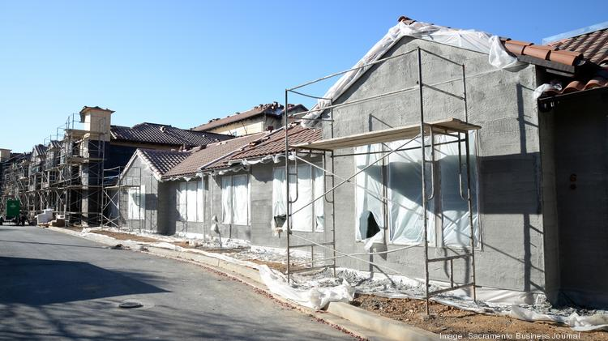
Enlarge
Oakmont Senior Living has five communities in the Sacramento region and is developing two more, this one in East Sacramento.
Dennis McCoy | Sacramento Business Journal

In the meantime, companies like Oakmont are on the hunt for more locations. Stevenson said his firm looks for properties of at least 3 acres, to make sure there’s room for parking and common areas. The company also looks for locations with a high barrier to entry and a more challenging entitlement process, to ensure the local market won’t be flooded with competition, he said.
Other attractive features include spots within 5 miles of transportation networks, and nearby medical care. The Oakmont facility in Roseville is near Sutter Roseville Medical Center. Oakmont of Folsom is across the street from Mercy Hospital of Folsom.
Stevenson said of the Sacramento population who by age and other factors are most likely to live somewhere like an Oakmont property, the “absorption” rate is only 10% to 12%. “We feel like we can build on that population,” he said.
One of the hottest markets
While senior housing developers snap up some infill locations, self-storage developers are often vying for other ones.
In recent years, the region has seen an adaptive reuse project of industrial property converted to self-storage in the Norwood area of Sacramento and the emergence of vehicle storage locations in Rancho Cordova and south Placer County.
Just this month, what’s likely the first urban project with self-storage as one of its uses opened at X Street and Broadway in Sacramento. Four-story Broadway Storage, by The Grupe Co., has almost 4,000 square feet of first-floor retail space, and an apartment project is planned on the neighboring lot to the south.
Even more so than senior housing, though, Sacramento has been one of the hottest markets in the U.S. for new self-storage projects, according to one report.

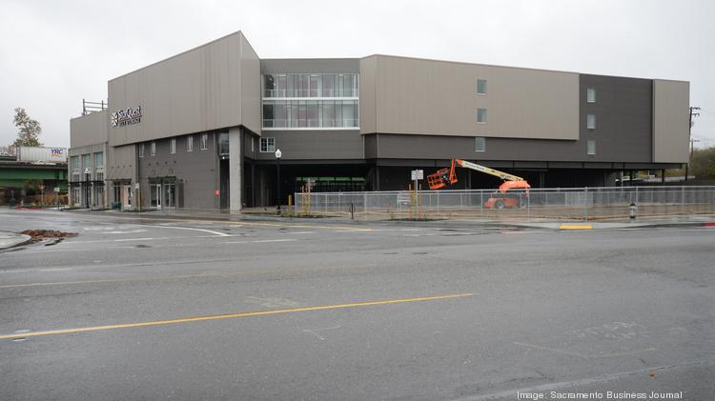
Enlarge
StorQuest on Third Street and Broadway is one of a growing number of self-storage developments in the region.
Dennis McCoy | Sacaramento Business Journal
According to the November 2019 self-storage report by Santa Barbara-based Yardi Matrix, the Sacramento region had the fifth-highest rate of growth in new units in the country. The October amount of units under construction, which wasn’t specified in the report, equaled about 16% of the entire supply in the region. That was also up from new supply equaling 15.6% of total supply the previous month, and from 15.1% in August 2019.
The report noted that Sacramento’s increase likely stems from population growth. As with senior housing, people moving from the Bay Area for cheaper housing need a place to put extra stuff.
An executive with a Sacramento-based self-storage company said during the Great Recession, self-storage companies adapted the quickest, and investors took note.
“People knew it was relatively stable, and it didn’t experience the same volatility as other sectors,” said Matt Garibaldi, president at Sacramento-based Storage Star. The company owns 14,000 units across the western U.S. in 11 properties.
The current trend in new home construction is toward smaller homes, which would likely benefit self-storage facilities, Garibaldi said. But that means new facilities have to be near those new housing tracts.
Garibaldi said he’s concerned too many self-storage facilities are being built everywhere. In Texas, he said, unit rents have fallen by about half because of overbuilding, a trend he’s worried will happen here. Yardi Matrix’s report shows in Sacramento, year-over-year rents have dropped by nearly 4% in climate-controlled units, though less so for ones without climate control.
“We’re certainly not seeing rents grow like they used to,” Garibaldi said. “There’s too much capital chasing it as an asset class.”
Garibaldi’s observation suggests another reason for the local growth of both senior housing and self-storage facilities in recent years.
Pete Nixon, a senior vice president with commercial real estate brokerage CBRE Sacramento, said what’s built is often a reflection of what doesn’t already exist. In the last economic cycle, the Sacramento region saw plentiful office, retail and industrial construction, so much so that demand hasn’t really pushed construction in any of those areas as much in this cycle. Higher land prices and fees also dampen enthusiasm for another office building or retail center to be built, said Nixon, who specializes in land transactions.
For capital investors, the goal is to put money into projects with demand, and where the sector isn’t overbuilt. To use the cool kids analogy, that capital switching trajectories to senior housing and self storage is like the movie trope of the gawky teenager who gets a makeover and becomes a center of positive attention overnight.
Both because of the capital investment and the demographics, Nixon said, he’s expecting both senior housing and self-storage to continue their growth.
As an example, he said, he recently listed a site in Folsom ideally situated for a senior housing. In shorter order, he got 10 offers.

